
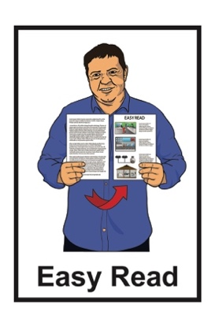

Information about what to do in an emergency in
Tāmaki Makaurau Auckland

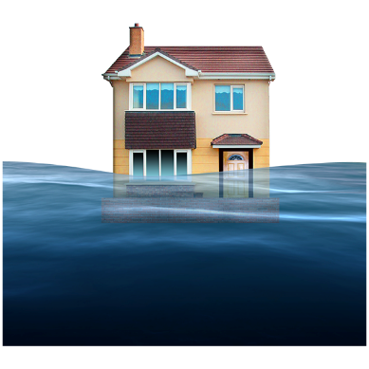
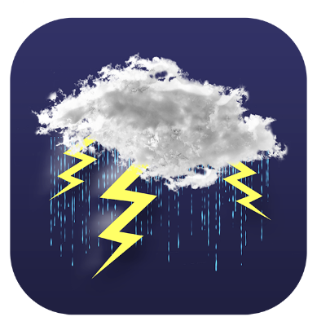

Published: February 2025

Before you start
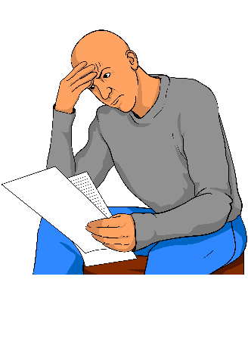

This information may upset some people when they are reading it.

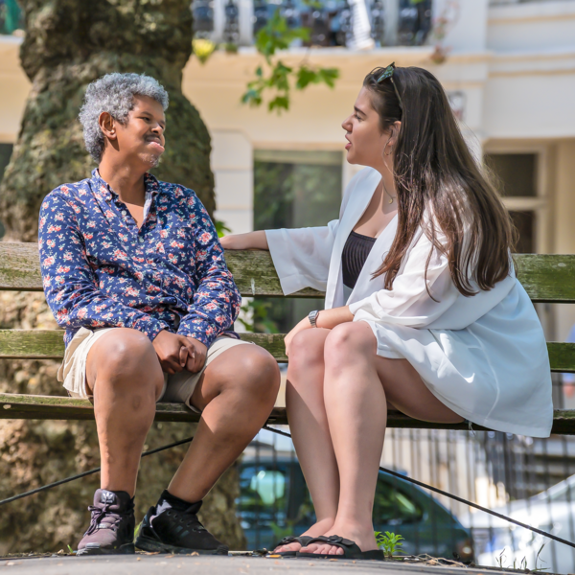
If you are upset after reading this document you can talk to your:
whānau / family
friends.

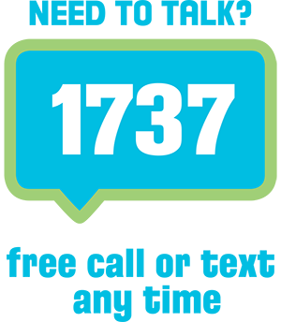
You can also contact Need to Talk by:
calling 1737
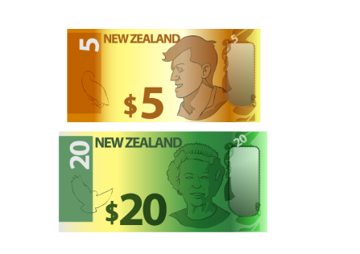

texting 1737

It does not cost any money to call / text 1737.

What you will find in here

Page number:


What this Easy Read is about 3

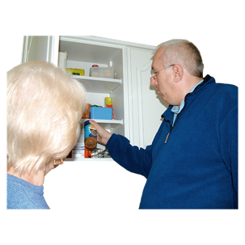
Top tips 5

Get ready for an emergency 10
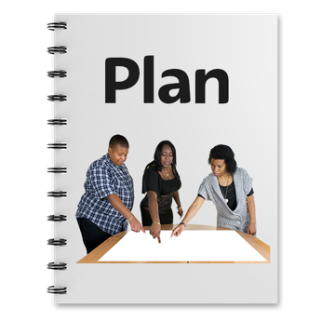

What to do in an emergency 13

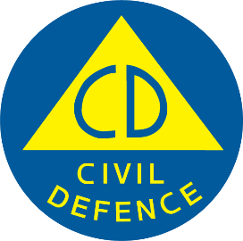
Contact information for Auckland Emergency Management 19

What this Easy Read is about

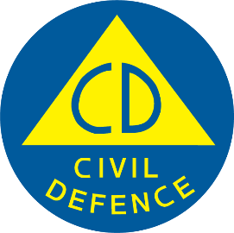
This Easy Read is from Auckland Emergency Management.

Auckland Emergency Management is part of Auckland Council.

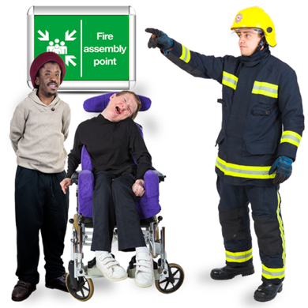
Auckland Emergency Management works to make sure everyone in Tāmaki Makaurau Auckland:
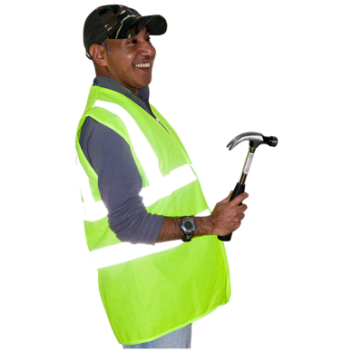
knows what to do in an emergency
is safe in an emergency
can put things right after an emergency.

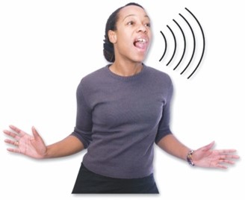
An emergency is when something dangerous happens that can put people at risk.

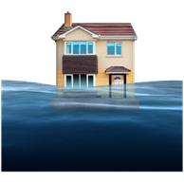
An emergency can be things like:
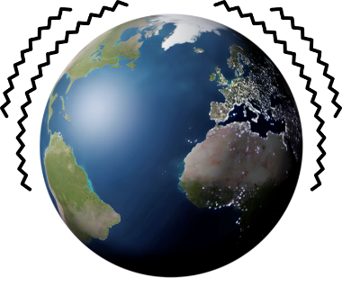
a flood
an earthquake
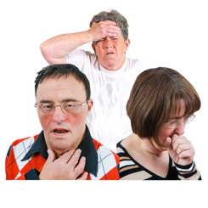
a pandemic which is when a lot of people get very sick very quickly.
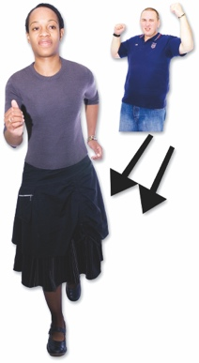
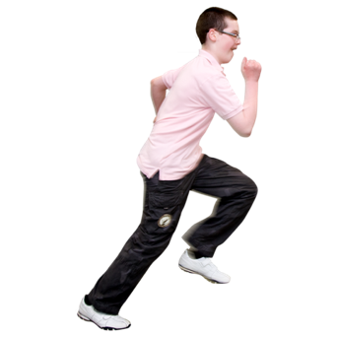

When an emergency happens everyone needs to act quickly so they can stay safe.


This Easy Read has information about what to do if there is an emergency in Tāmaki Makaurau Auckland.

Top tips


The next page has some tips about how to get ready for an emergency.

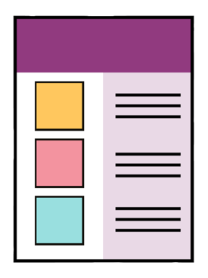
There will be more information about the tips on the following pages.

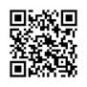
Some of the tips have QR codes beside them.

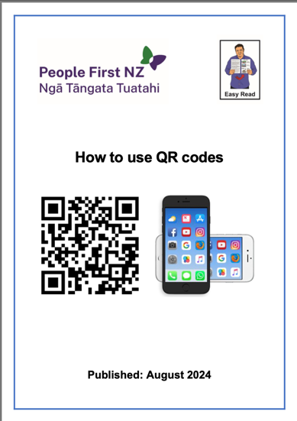
QR codes are a way of sharing links to websites.

There is an Easy Read about how to use QR codes at:

https://tinyurl.com/2nrv7h5d

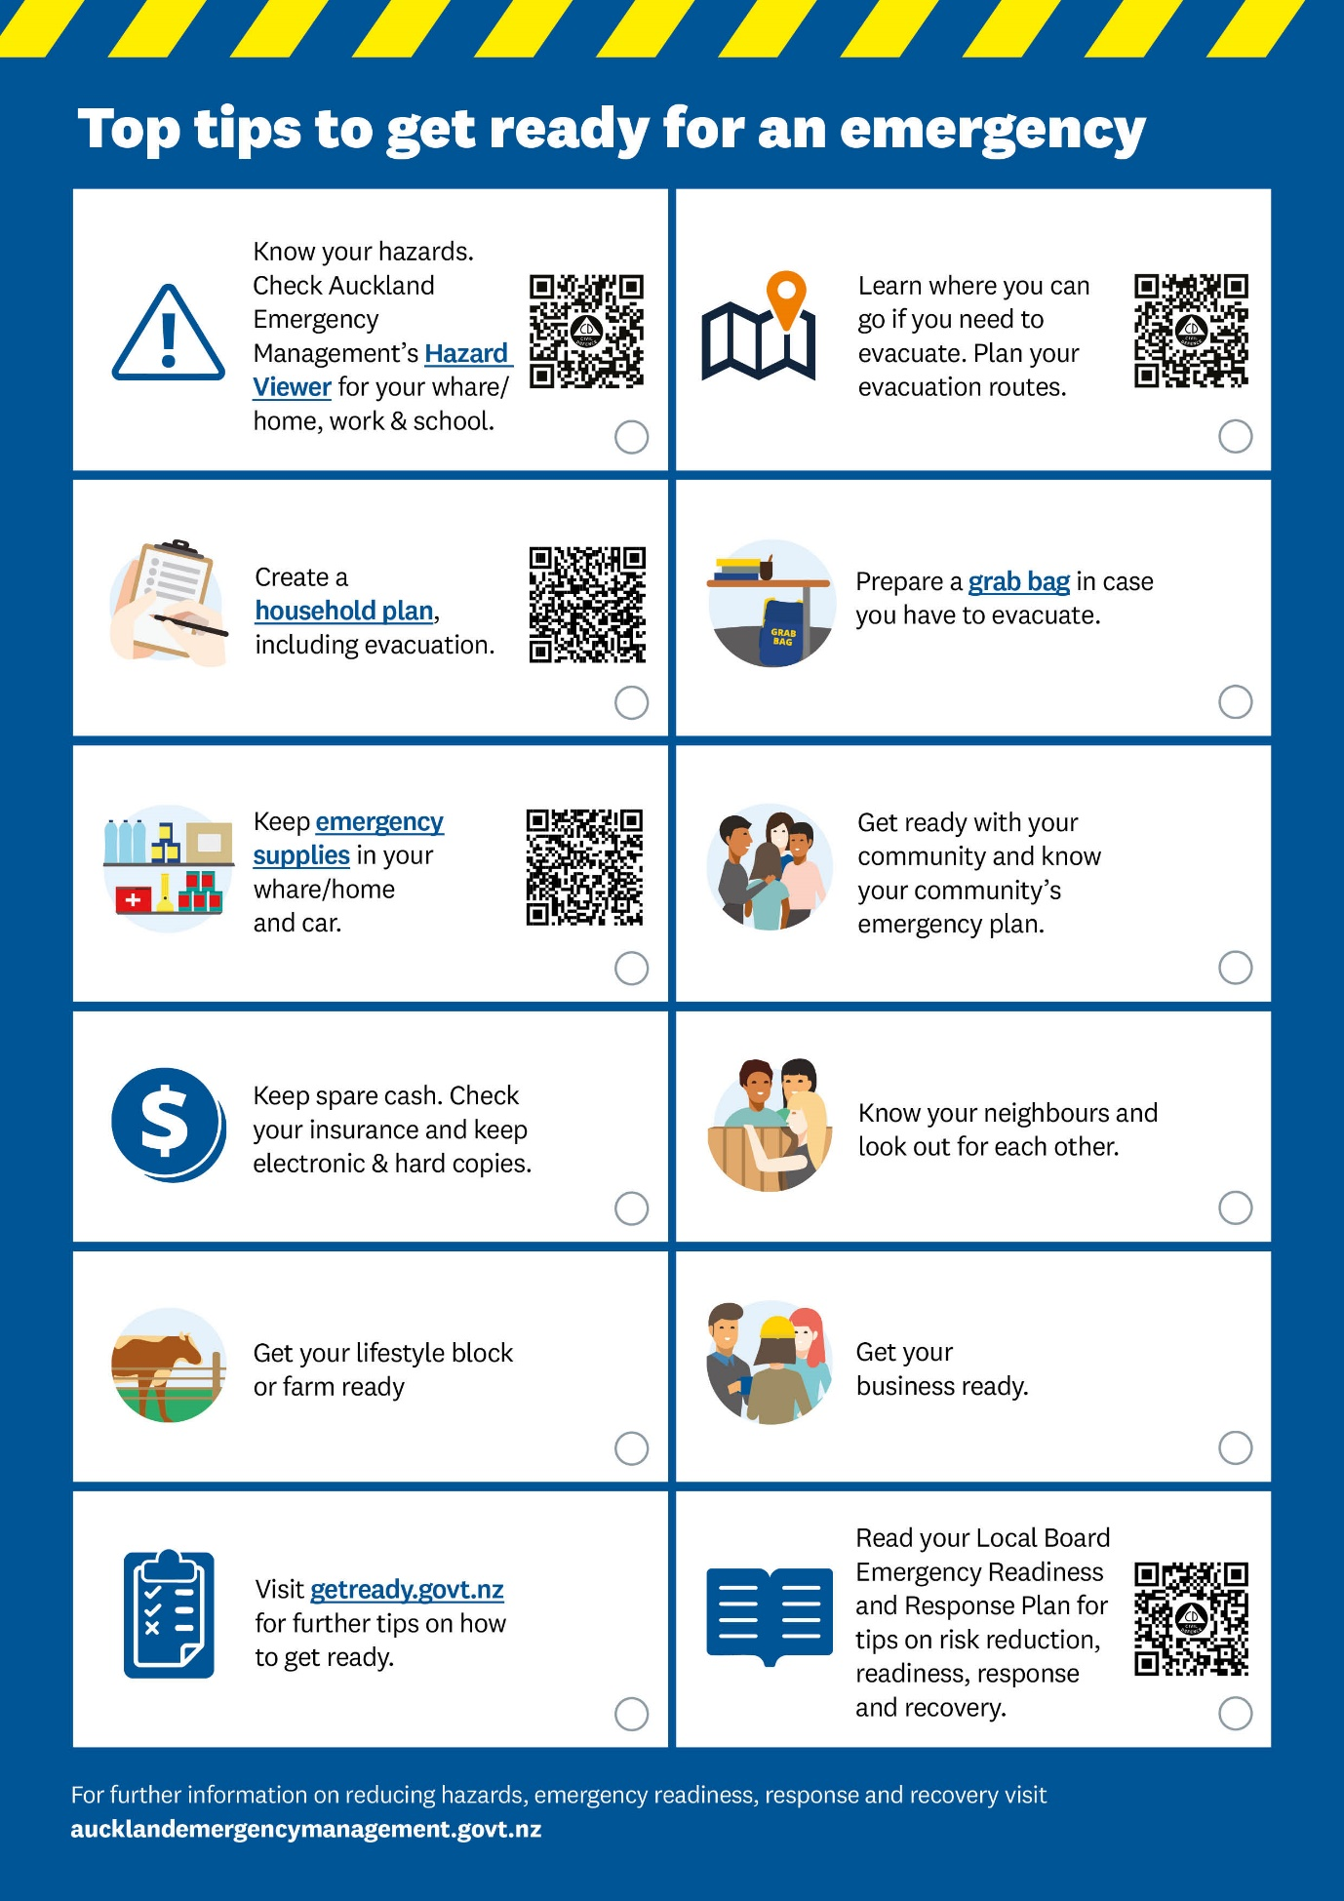
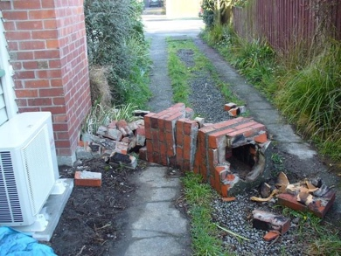
A hazard is something that could do a lot of harm like:
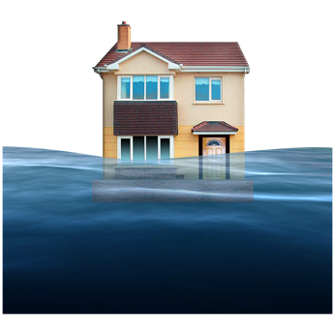
an earthquake
a flood.

Evacuate means to:
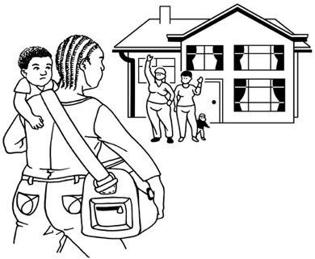
leave somewhere that is not safe

and
go to somewhere that is safe.

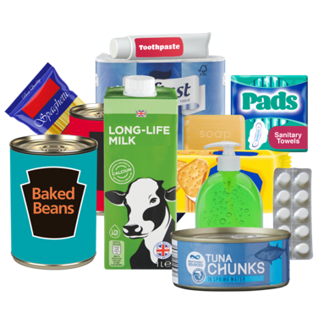
Emergency supplies are things you keep in your home to use when there is an emergency.

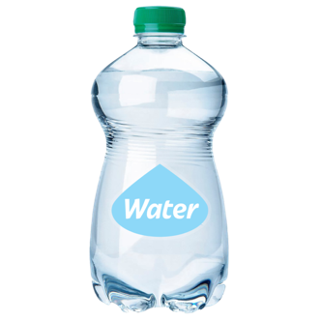
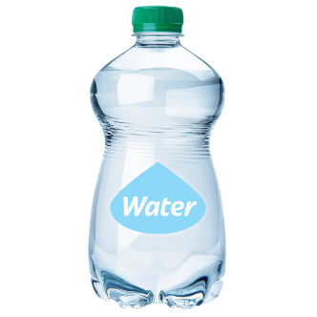
Emergency supplies can be things like:
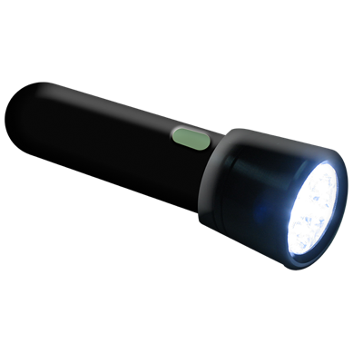
water
food
a torch.
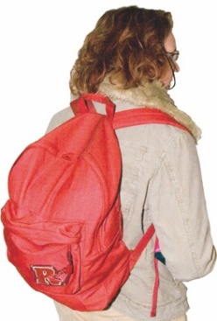

A grab bag is a bag of things to take with you if you need to evacuate.
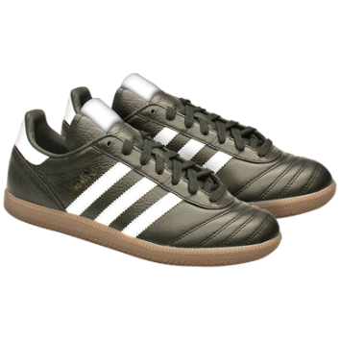

Grab bags can have things like:
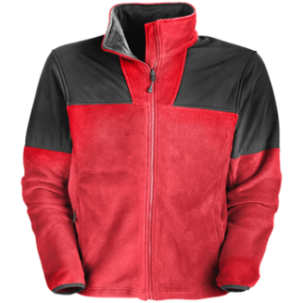
sturdy / strong shoes
warm clothes
medicine you might need.
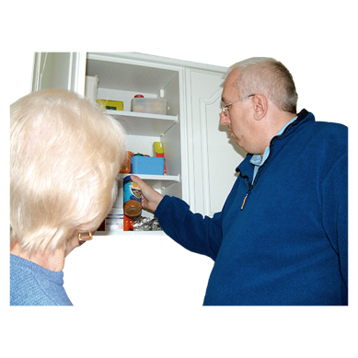
It is a good idea to get your emergency supplies / grab bag together when there is not an emergency happening.

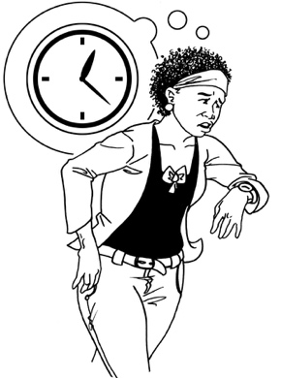
You might not have time to find everything when there is an emergency.

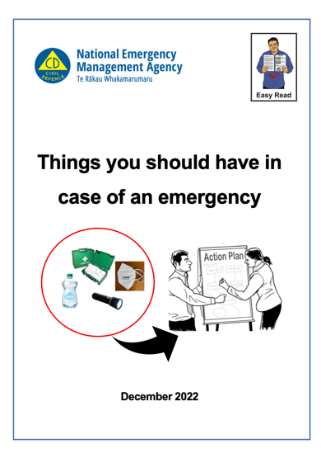
There is more information about emergency supplies / grab bags in the Easy Read:

Things you should have in case of an emergency


You can find this Easy Read at:

https://tinyurl.com/yc5tt895

Get ready for an emergency

There are lots of things you can do to get ready for an emergency.

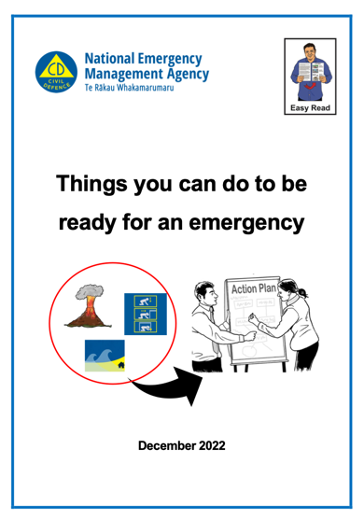
You can find information about getting ready for an emergency in the Easy Read:

Things you can do to be ready for an emergency

https://tinyurl.com/yw7y9wwy
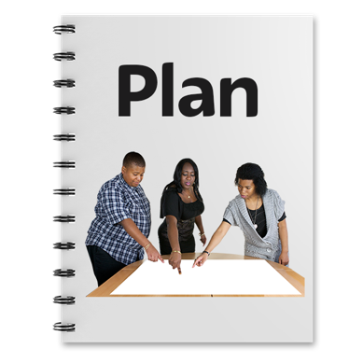

It is a good idea to make a household plan so that everyone in your house knows what to do in an emergency.

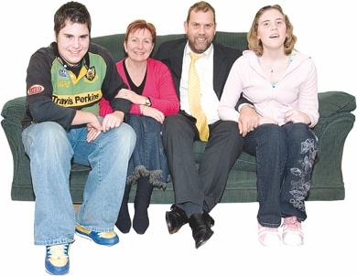
You can talk about what to do in an emergency with:
your whānau / family
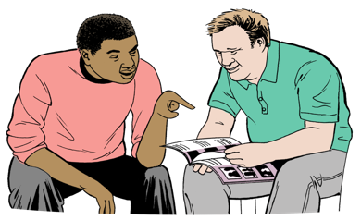
the people you live with
your carers / support workers.

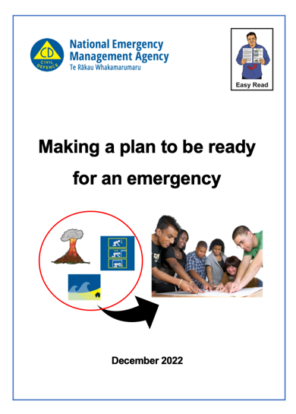
You can find more about making a household plan in the Easy Read:

Making a plan to be ready for an emergency

You can find this Easy Read at:

https://tinyurl.com/bdfkc9be

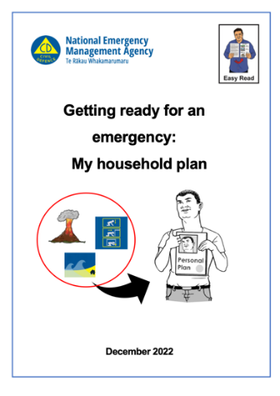
There is also an Easy Read form you can use to make a household plan at:

https://tinyurl.com/4pafy2cu

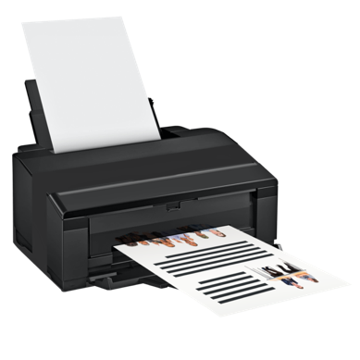
You can print the form and fill it out with:
your whānau / family
the people you live with
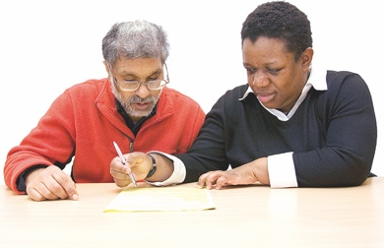
your carers / support workers.

What to do in an emergency
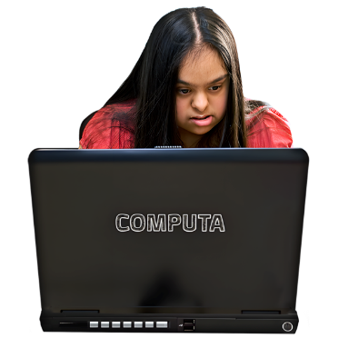

The Get Ready website has Easy Read information about what to do in lots of different emergencies.

You can find the Easy Read on the Get Ready website is at:

https://tinyurl.com/mrzvaeuh

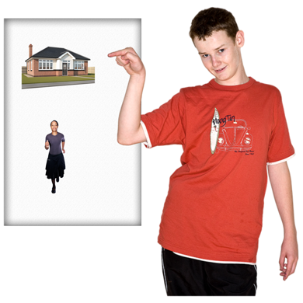
In an emergency you will have to decide if it is safer to:
stay at home / where you are
evacuate to somewhere else.

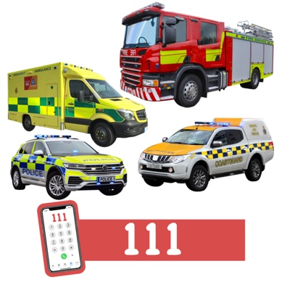
Use a phone to call 111 if someone is:
badly hurt
in danger.

You can use your household plan to support you to decide what to do.

If you are safe to stay at home you should:
use your emergency supplies
check on your neighbours / people nearby
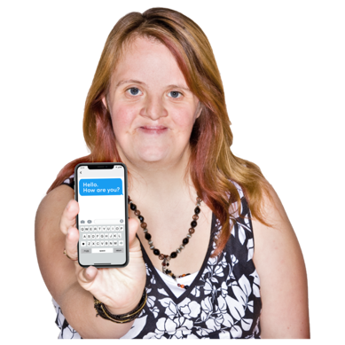
stay in touch with your:
- whānau / family
- friends.

You can get information about what is happening in an emergency from Auckland Emergency Management.

Information about how to get in touch with Auckland Emergency Management is at the end of this Easy Read.

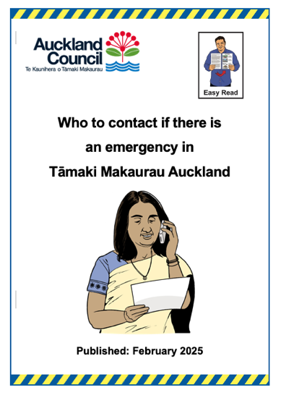
There is an Easy Read document about where to get information in an emergency called:

Who to contact if there is an emergency in Tāmaki Makaurau Auckland:

You can find the Easy Read online at:

www.aem.govt.nz/alternate-formats
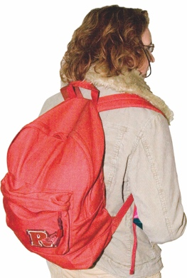
If you decide to evacuate you should take your grab bag with you.

When you evacuate you could go and stay with someone like a:
whānau / family member
friend.

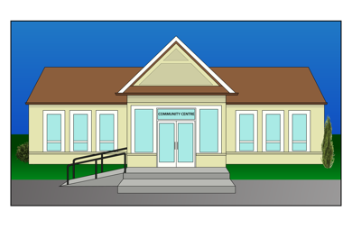
If you do not have a safe place to evacuate to you can go to a civil defence centre / community emergency hub.

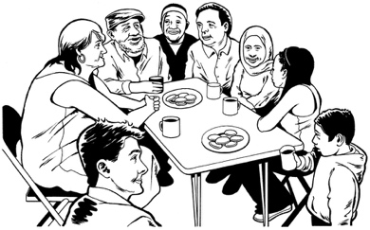
A civil defence centre / community emergency hub is a place where people who have evacuated can go to support each other.

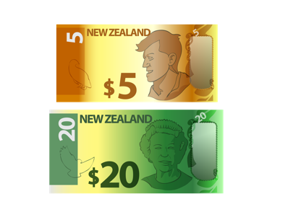
You do not have to pay money to go to a civil defence centre / community emergency hub.

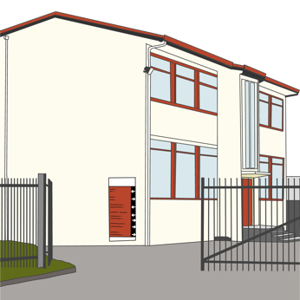
Civil defence centres / community emergency hubs are usually in places like:
schools
community centres.

Auckland Emergency Management has information about civil defence centres / community emergency hubs.

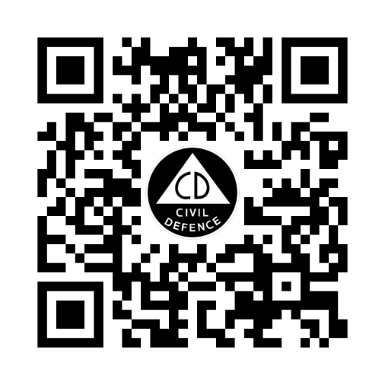
Use this QR code to find a map of civil defence centres that might be open in Tāmaki Makaurau Auckland.

You can also find the map of civil defence centres online at:

www.aem.govt.nz/cdc

Contact information for
Auckland Emergency Management

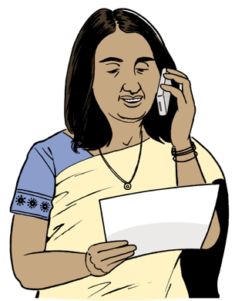
In an emergency you can phone Auckland Emergency Management on:

0800 222 200
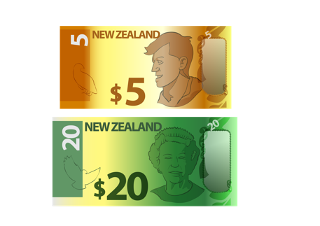

It does not cost money to call this number.

The Auckland Emergency Management website is at:

www.aem.govt.nz
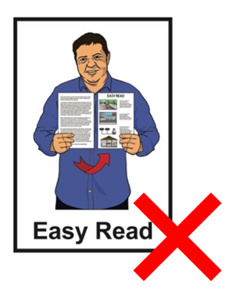

The website is not in Easy Read.

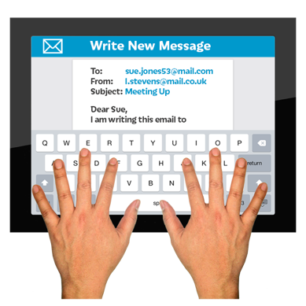
You can email Auckland Emergency Management at:

aeminfo@aucklandcouncil.govt.nz

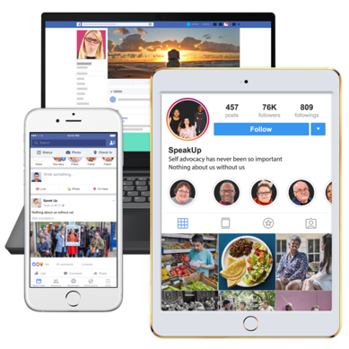
You can also find Auckland Emergency Management on social media by looking up:


X / Twitter at:

@AucklandCDEM

Facebook at:

Auckland Emergency Management

This information has been written by Auckland Emergency Management.

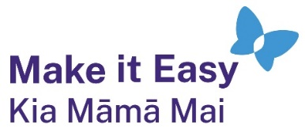
It has been translated into Easy Read by the Make it Easy Kia Māmā Mai service of People First New Zealand Ngā Tāngata Tuatahi.
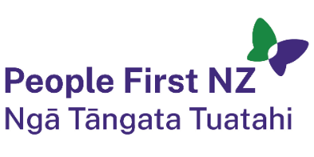
The ideas in this document are not the ideas of People First New Zealand Ngā Tāngata Tuatahi.

All images used in this Easy Read document are subject to copyright rules and cannot be used without permission.


Make it Easy uses images from:

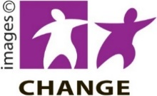
- Photosymbols

- Change Images



- Huriana Kopeke-Te Aho

- SGC Image Works

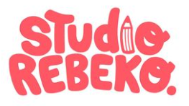
- T Wood

- Studio Rebeko.

