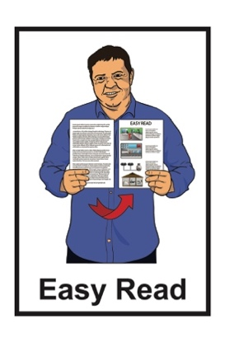


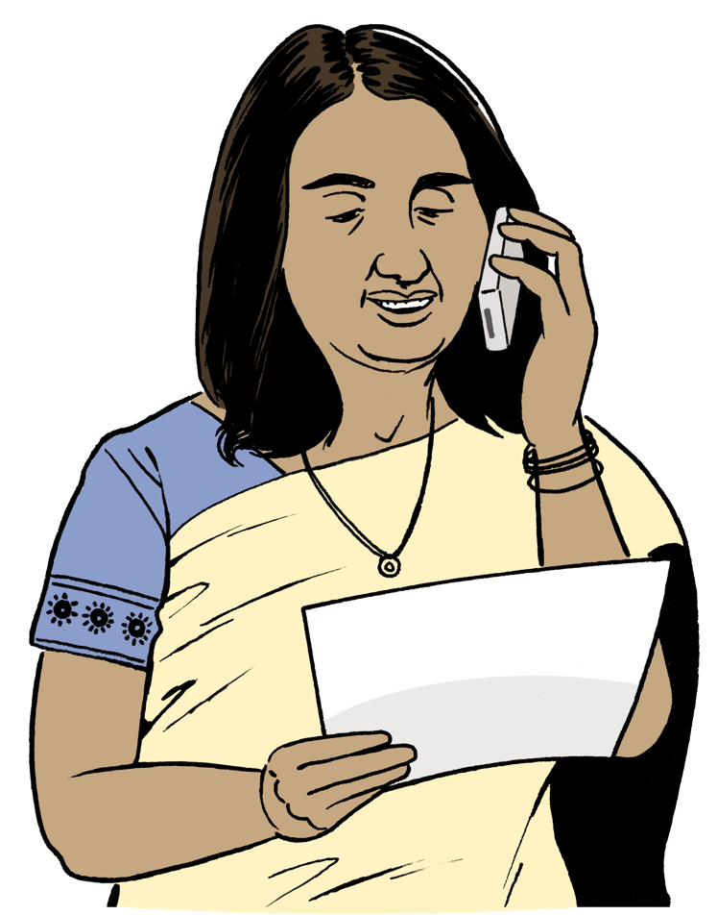
Who to contact if there is
an emergency in
Tāmaki Makaurau Auckland

Published: February 2025

Before you start
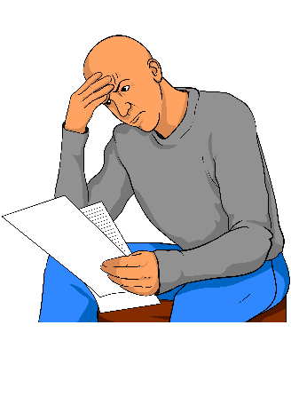

This information may upset some people when they are reading it.


If you are upset after reading this document you can talk to your:
whānau / family
friends.

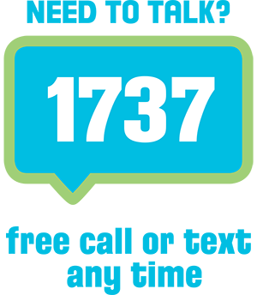
You can also contact Need to Talk by:
calling 1737


texting 1737

It does not cost any money to call / text 1737.

What you will find in here

Page number:

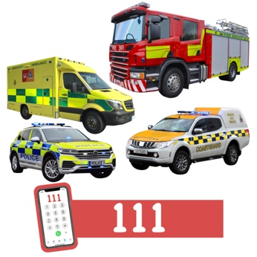
What this Easy Read is about 4

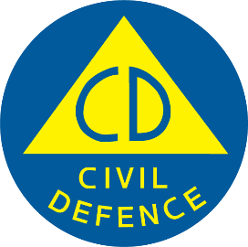
If there is danger 7

Auckland Emergency Management 9
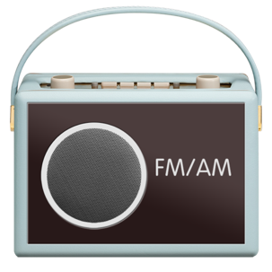

Get information on the radio 12

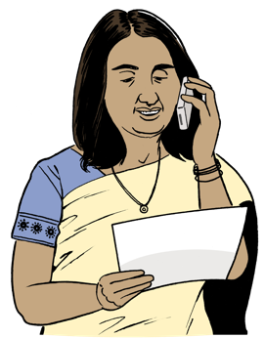
Report a problem 17

Page number:


Kāinga Ora 30

Auckland Council 31

What this Easy Read is about

This Easy Read is from Auckland Emergency Management.

Auckland Emergency Management is part of Auckland Council.

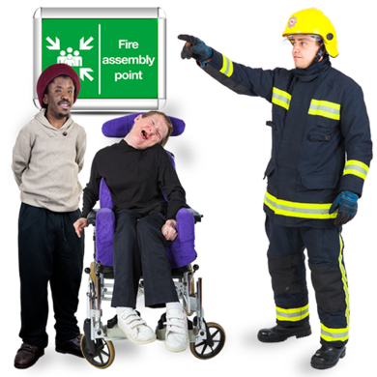
Auckland Emergency Management works to make sure everyone in Tāmaki Makaurau Auckland:
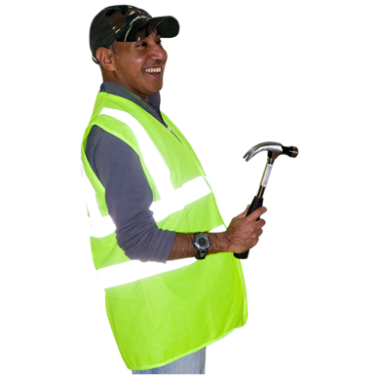
knows what to do in an emergency
is safe in an emergency
can put things right after an emergency.

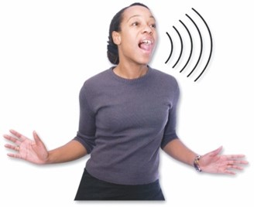
An emergency is when something dangerous happens that can put people at risk.

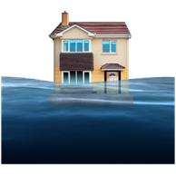
An emergency can be things like:
a flood
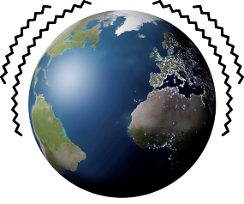
an earthquake

a pandemic which is when a lot of people get very sick very quickly.



When an emergency happens everyone needs to act quickly so they can stay safe.


This Easy Read has information about:
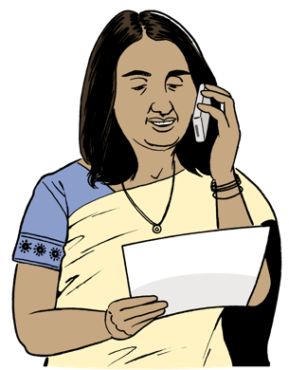
where to find information when there is an emergency
who to contact when there is an emergency.

If there is danger

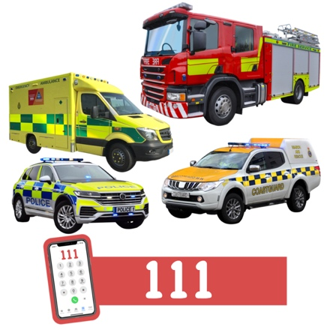
Use a phone to call 111 if you need:
the police
the fire service
an ambulance.
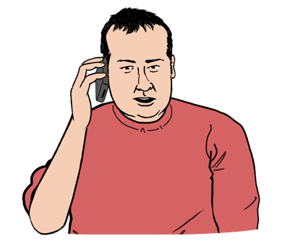

Call 111 if:
someone is badly hurt

someone is very sick
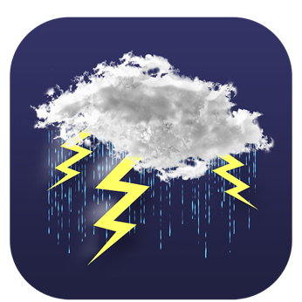
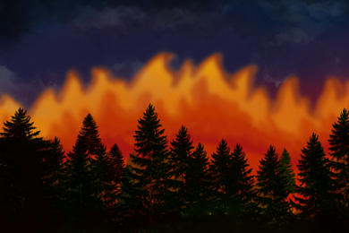
something is happening that is likely to hurt someone – for example a tree is about to fall down in a storm
something like a fire is going to damage houses / buildings.
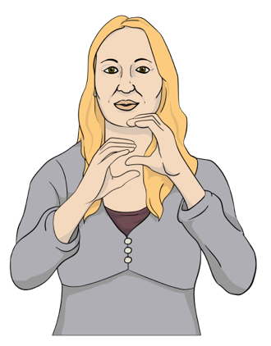
You can sign up to use the Emergency Texting Service 111 TXT if you find it hard to:
hear
talk on the phone.


111 TXT is a service that lets you use text messages to tell the police about emergencies.

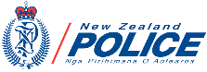

You can register for 111 TXT on the New Zealand Police website at:

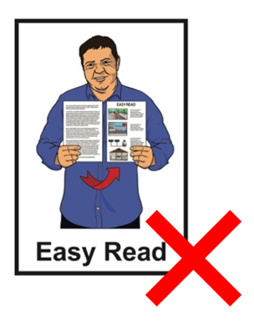
https://tinyurl.com/2c75hay7

The website is not in Easy Read.

Auckland Emergency Management

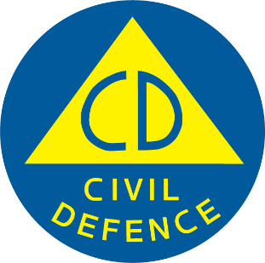
Auckland Emergency Management can give you information about what to do in different emergencies.


Auckland Emergency Management also puts out alerts about emergencies in Tāmaki Makaurau Auckland.
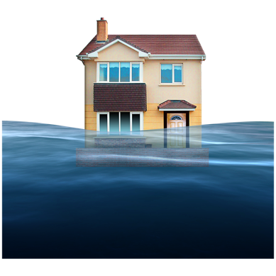

Alerts tell you about:
emergencies that are happening now
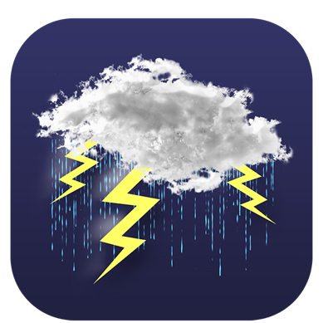
things that could become emergencies at a later time like if very bad weather is forecast.

You can phone Auckland Emergency Management on:

0800 222 200


It does not cost money to call this number.


The Auckland Emergency Management website is at:

www.aem.govt.nz

The website is not in Easy Read.


You can email Auckland Emergency Management at:

aeminfo@aucklandcouncil.govt.nz


You can also find Auckland Emergency Management on social media by looking up:


X / Twitter at:

@AucklandCDEM

Facebook at:

Auckland Emergency Management

Get information on the radio

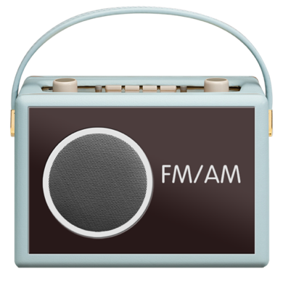
In an emergency you can listen to the radio to find out:
what is happening
what to do.
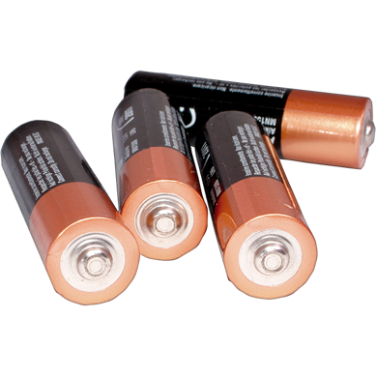

It is a good idea to have a radio that is powered by batteries to use when there is an emergency.

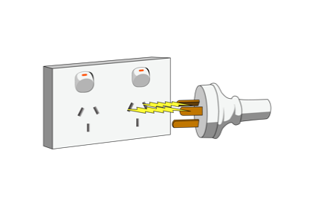
A battery radio will work if the electricity is off.

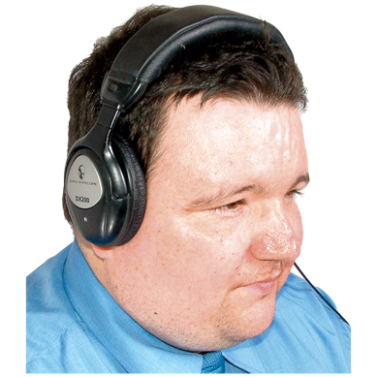
The radio stations listed on this page will have emergency information for
Tāmaki Makaurau Auckland.

The number after the name of the radio station is the number to set your radio to so you can listen to that station.

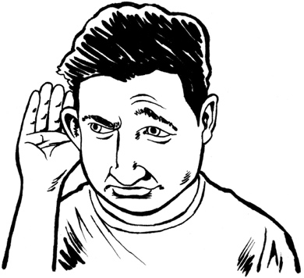
Radio New Zealand

756 AM / 101.4 FM

More FM

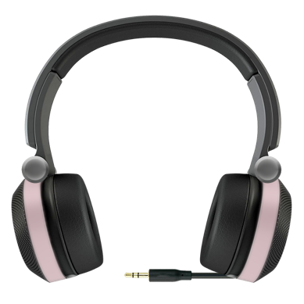
91.8 FM

Newstalk ZB

89.4 FM

Here are some more radio stations that will have emergency information for Tāmaki Makaurau Auckland.

Planet FM

104.6 FM

The Hits

97.4 FM


Humm

104.2 FM

New Zealand Chinese Radio

90.6 FM

Here are some more radio stations that will have emergency information for Tāmaki Makaurau Auckland.

Pacific Media Network

531 AM
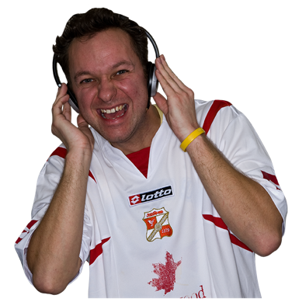

Radio Apna

990 AM

Radio Samoa


1593 AM

Radio Spice

88 FM

Here are some more radio stations that will have emergency information for Tāmaki Makaurau Auckland.

Radio Tama-Ohi
87.7 FM

Radio Tarana

1386 AM

Radio Waatea

603 AM

Report a problem

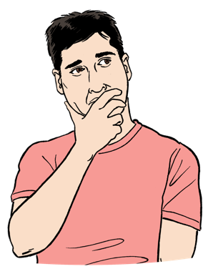
This section is about what to do when there is a problem that:
needs to be fixed

but
is not putting anyone in danger.

Use your phone to call 111 if there is serious danger.

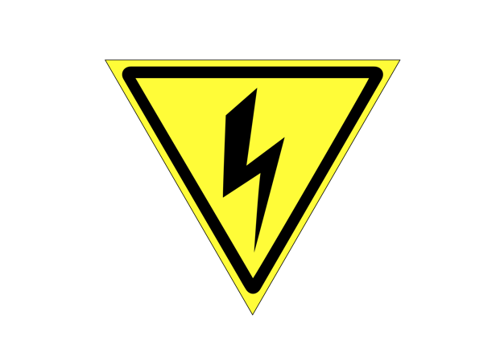
Electricity

Contact your electricity distribution company if your electricity is not working.

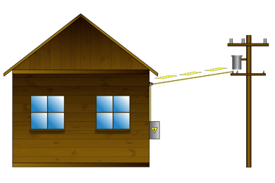
Electricity distribution companies are in charge of power lines.

Vector Energy is the electricity distribution company for most of Auckland from:
Wellsford in the north

to
Papakura / Manukau in the south.
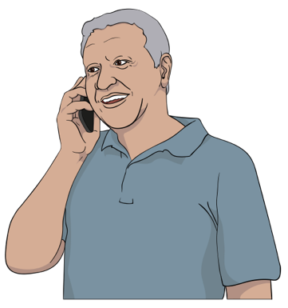

You can phone Vector Energy on:

0508 832 867

You can also report a problem with your electricity on the Vector Energy website at:

https://tinyurl.com/fva96bhs

The website is not in Easy Read.

Counties Energy is the electricity distribution company for the rest of Tāmaki Makaurau Auckland from:
southern Papakura in the north

to
Waikaretu in the south

You can phone Counties Energy on:

0800 100 202

You can also report a problem with your electricity on the
Counties Energy website at:

https://tinyurl.com/yc5v7m3w

The website is not in Easy Read.

Gas
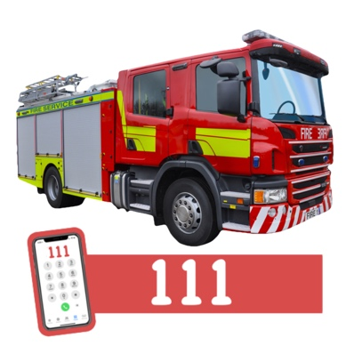
Call the fire service on 111 if you:
smell gas
think there is a gas leak.

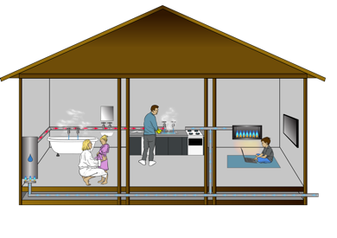
Here gas means gas that comes to your house in pipes for things like:
cooking
heating.
For other problems with your gas get in touch with your gas company.

If your gas company is Vector Gas you can phone them on:

0800 764 764

If your gas company is
Counties Energy you can phone them on:

0800 100 102

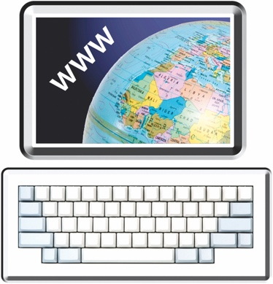

Internet

Contact your internet company if there is a problem with your internet.


You can find out if there is a problem with the internet near you on this website:

https://tinyurl.com/4xj3xksx

The website is not in Easy Read.

Flooding

You can report flooding by phoning Auckland Council on:

(09) 301 0101

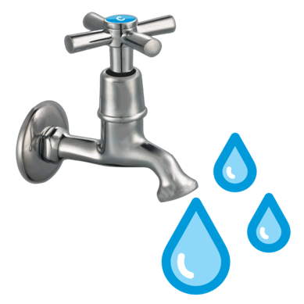
Water supply / wastewater

Water supply means the water that comes out of your taps.

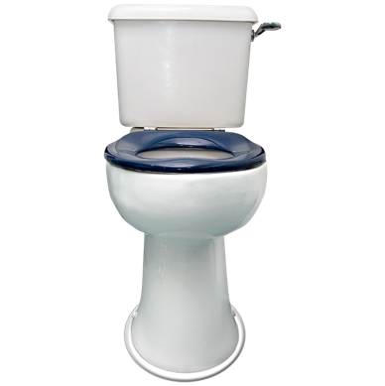
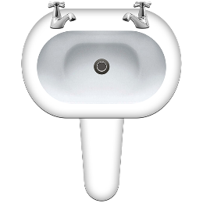
Wastewater means everything that goes down your:
sink
toilet.

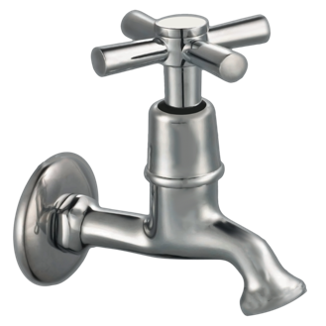
You can report problems with your water supply / wastewater to Watercare.

Watercare is the part of
Auckland Council in charge of
water supply / wastewater

You can phone Watercare on:

(09) 442 2222

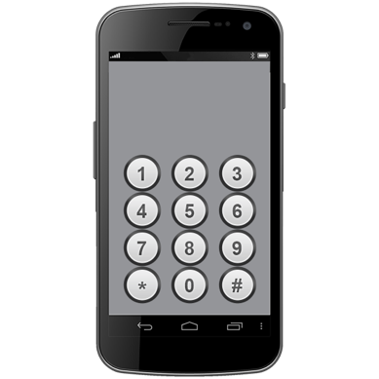
When the call starts press 1 on your phone to report a problem.

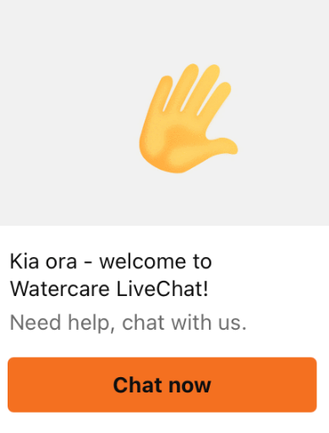
You can use the live chat on the Watercare website to get support at:

www.watercare.co.nz

You will have to type in your:
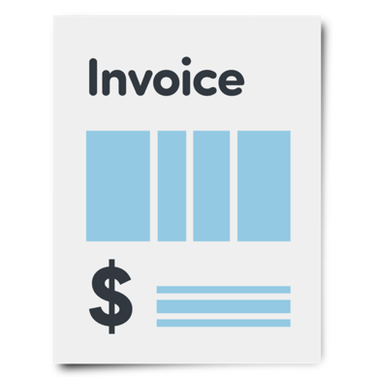
name
address
the account number on your water bill.

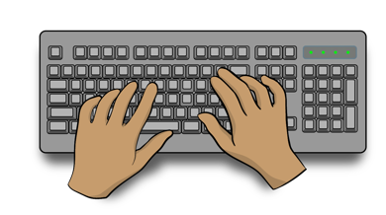
Then you can type a message to a person from Watercare.

You can see information about problems with water supply / wastewater on the Watercare website at:

https://tinyurl.com/jmte8jy7

The website is not in Easy Read.

Fallen trees / debris

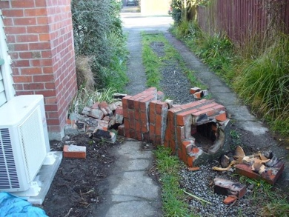
Debris means big bits of rubbish like:
rocks
parts that have fallen off buildings.


You can report fallen trees / debris on the Auckland Council website at:

https://tinyurl.com/yyv96kbu

Click on the box labelled:

Footpaths, roads, streetlights, parking and public transport.

Roads

If there is a problem with a
state highway that needs to be fixed you should phone New Zealand Transport Agency Waka Kotahi straight away on:

0800 44 44 49
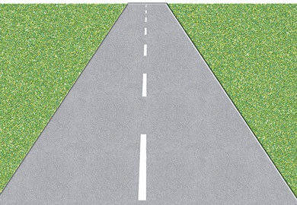

State highways are big roads that go between cities / towns.
If there is a problem on a road that is not a state highway phone Auckland Transport on:

(09) 355 3553

To find out if there are problems on state highways go to the
New Zealand Transport Agency Waka Kotahi website at:

https://tinyurl.com/bdhsuya5

To find out if there are problems on other roads in Tāmaki Makaurau Auckland go to the Auckland Transport website at:

https://tinyurl.com/38fkf8p6

These websites are not in
Easy Read.

Landslides
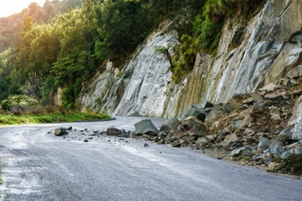
A landslide is when a lot of
earth / rock falls off a hill.

If you think a landslide is going to happen:
make sure everyone is safe
phone 111.

Kāinga Ora

If you live in a home owned by Kāinga Ora you can tell them about any problems with your home.

You can phone Kāinga Ora on:

0800 801 601

You can also get in touch with
Kāinga Ora on their website at:

https://tinyurl.com/6pa9hs9a

The website is not in Easy Read.

Auckland Council

You can get in touch with Auckland Council for more information about emergencies in Tāmaki Makaurau Auckland.

You can phone Auckland Council on:

(09) 301 0101

You can go to the Auckland Council website at:

www.aucklandcouncil.govt.nz

The Auckland Council website is not in Easy Read.

This information has been written by Auckland Emergency Management.


It has been translated into Easy Read by the Make it Easy Kia Māmā Mai service of People First New Zealand Ngā Tāngata Tuatahi.
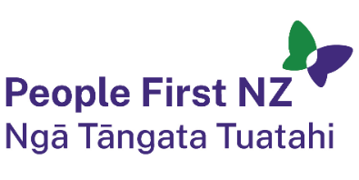
The ideas in this document are not the ideas of People First New Zealand Ngā Tāngata Tuatahi.

All images used in this Easy Read document are subject to copyright rules and cannot be used without permission.


Make it Easy uses images from:


- Photosymbols

- Change Images



- Huriana Kopeke-Te Aho

- SGC Image Works


- T Wood

- Studio Rebeko.

